**VIP @ Aine Ai**

**Submitted by: Aditi Chatterjee**

**PROJECT: Black Friday Sales Analysis (MS-Excel)**

This file contains screenshots of a project I did as a data science intern. This project included creating visuals and dashboards in MS-Excel to analyze Black Friday sales.

1. **Introduction Dashboard:**

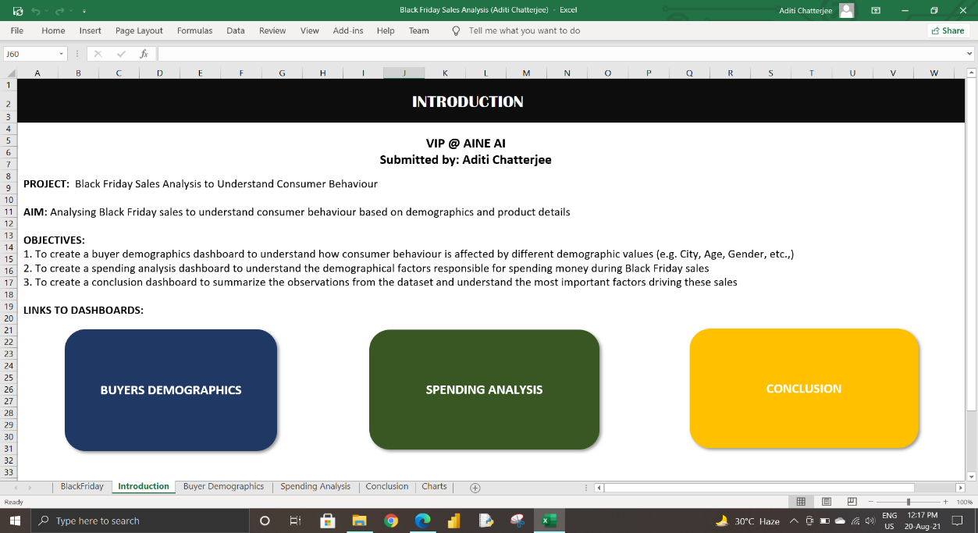

1. **Buyers Demographic Dashboard:**

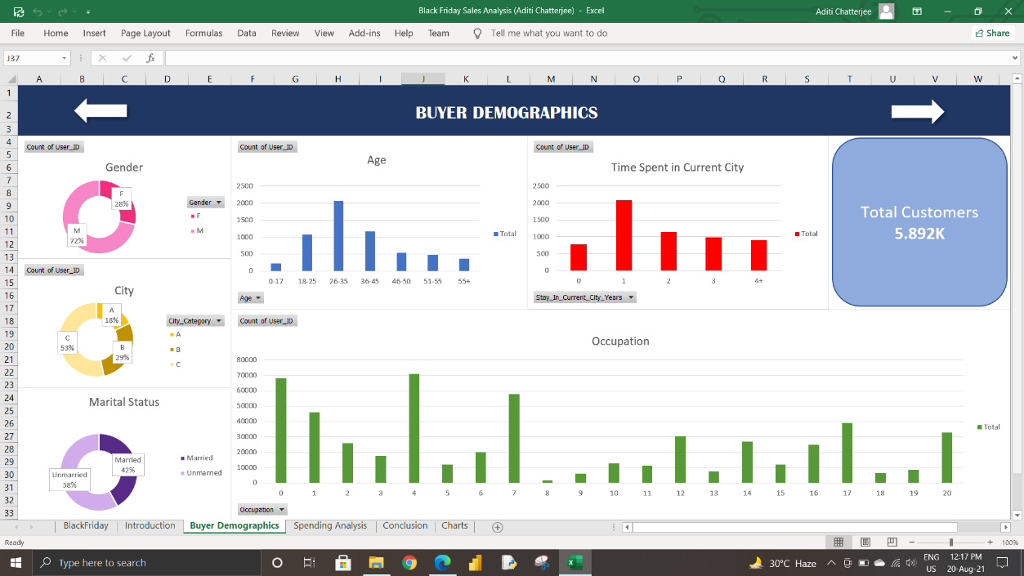

1. **Spending Demographic Dashboard:**

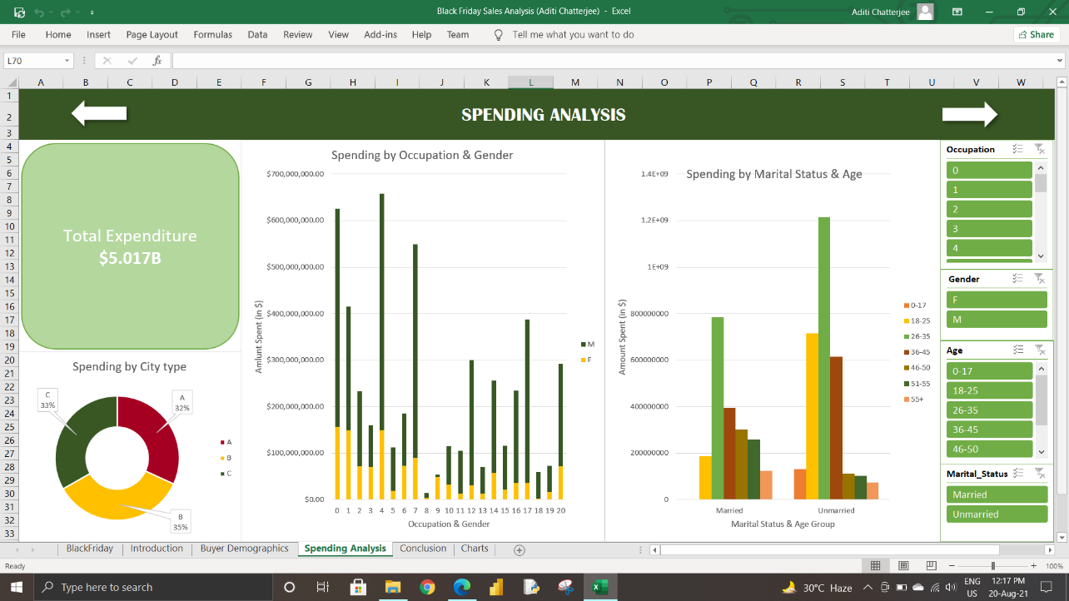

1. **Conclusion Dashboard:**

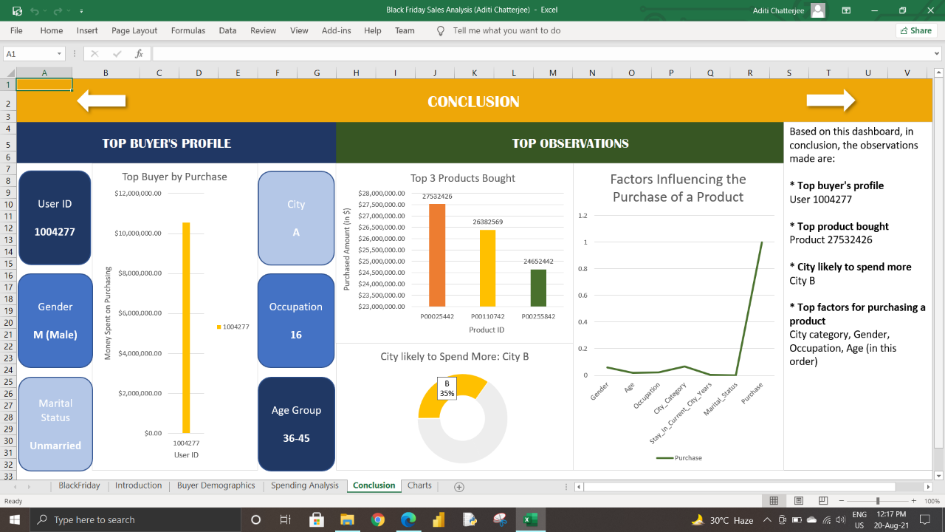

1. **Worksheet to Store all the Charts:**

